

**Title of Proposed Program:**

*[Insert program title]*

**Effective Term:**

*[Insert proposed start date]*

**Item 1. Program Goals and Objectives**

*The Associate in Art/Science in* ***[insert degree title]*** *degree is designed to prepare students to acquire knowledge and academic skills to transfer to a four-year institution and earn a baccalaureate degree in* ***[insert degree title]*** *or similar major.*

*The program outcome goals for students completing the program are:*

*[Insert program student learning outcomes only, no assessments]*

**Item 2. Catalog Description**

*[Insert current catalog description].*

**Item 3. Program Requirements**

*[Insert* ***current program’s******table of required courses*** *from* ***CurriCUNET****]*

**Note:** *Add a 4th column to include course sequencing. The college needs to demonstrate how the student completes each course, such as Year 1 Fall, Year 2 Spring, Year 3 Fall, Year 4 Spring. It is meant to show that a student can complete the degree or certificate in a timely manner.*

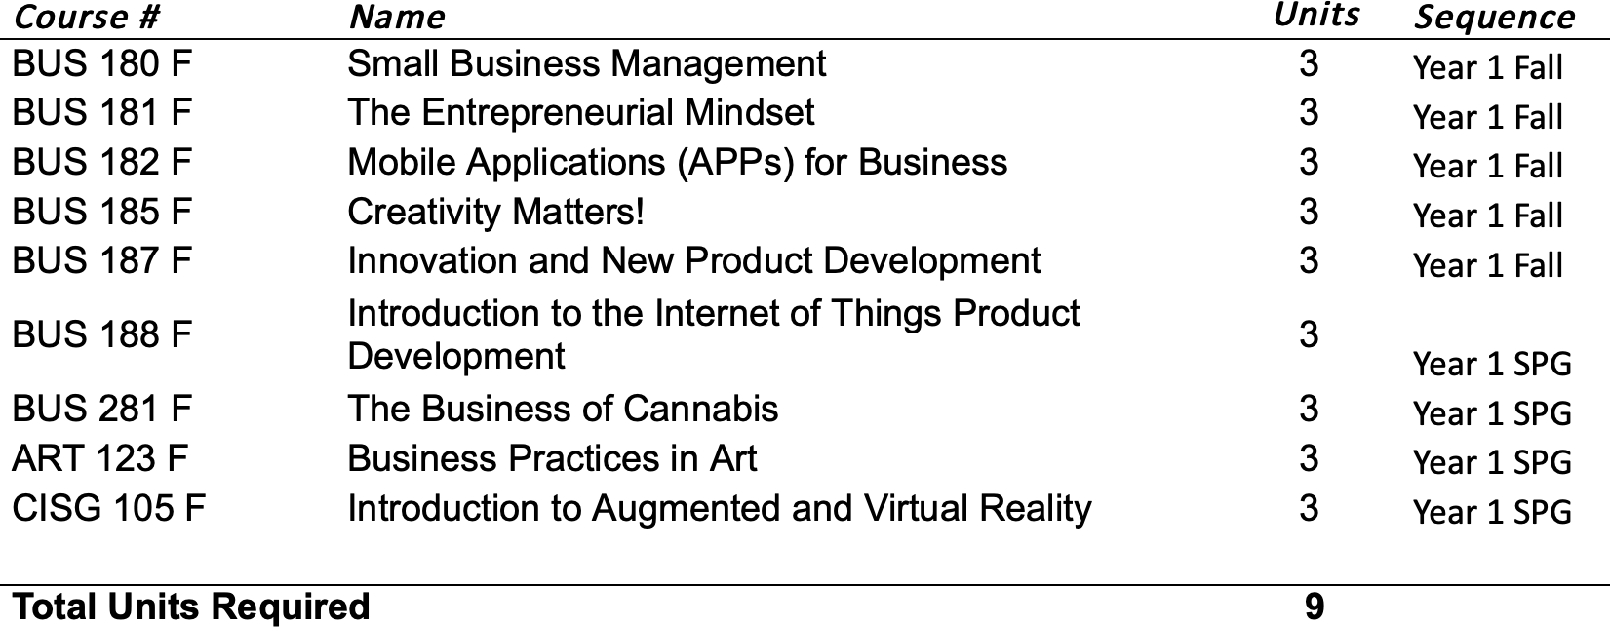**Example:**

***The table below is completed by the Articulation Office. Please contact Kevin Tran (***[*Ktran1@fullcoll.edu*](mailto:Ktran1@fullcoll.edu)***)***

|  |  |  |  |
| --- | --- | --- | --- |
| Major Total: | 18 units | | |
| GE Pattern: | CSU GE 39 units | IGETC 37 units | Local GE 24 units |
| Electives (as needed) (CSU transferrable): |  |  |  |
| Double-Counted: |  |  |  |
| Total Degree (maximum): | 60 units | | |

**FACULTY ORIGINATOR CHECKLIST:**

1. Complete Items 1, 2, and 3 above
2. Complete Major total counts
3. **Attach** this document in the **“Attach Files”** page on CurriCUNET

